Disclaimer
It is highly recommended that any person planning to use Artificial Intelligence (AI) in the workplace familiarises themselves with the BVA Policy Position on Artificial Intelligence in the Veterinary Profession to get an understanding of definitions, safe use principles, and common uses in the profession.
The following template is designed to be high level and should be amended to suit your workplace, complementing existing workplace policies, especially around data privacy.

Policy on the use of Artificial Intelligence (AI) in veterinary practice
Purpose of the AI policy
This policy aims to provide clear guidelines and expectations on the responsible and appropriate use of AI by [Practice name] employees, to ensure that it is used effectively and ethically while safeguarding [Practice name] integrity, reputation and the privacy of its data.

[Practice name] acknowledges that currently AI can only support, and not replace, professional skills, creativity and judgement.

Responsibilities
Managers’ responsibilities
Managers should discuss with their team members how they may be able to use AI to support their work and provide guidance and learning opportunities as appropriate.

Managers will make [Practice name] AI use policy clear to all employees and ensure that AI is being used appropriately and responsibly in their work.

They will act if they become aware that an employee is not complying with [Practice name] AI use policy by speaking to the employee concerned and flagging it with the relevant [Manager/Decision maker].

Employees’/ Wider vet team responsibilities
Employees have a responsibility for familiarising themselves with [Practice name] AI policy and following the principles and guidelines below.

Principles of the AI policy
- [Practice name] aims for a balanced approach to AI use in the workplace by ensuring it is properly understood and used appropriately, responsibly and transparently.
- The vet team will be mindful of [Practice name]’s values and expected standards of behaviour when accessing, interpreting, and acting on material generated by AI in the course of their work. When used clinically, AI will only be used as a tool to aid judgement, not replace it. The clinical team - vets and vet nurses - must always use their professional expertise and judgement when using AI tools.
- For transparency, every member of the vet team should clearly flag where they have systematically used AI in their work.
- Existing policies on acceptable IT and data use and data protection, including GDPR compliance, apply when using AI tools. Employees should and must treat all data with the same level of security and care and must not input confidential [Practice name] or client data into third-party applications without prior approval from the relevant [Decision maker].
- Employees must exercise caution when agreeing to external T&Cs, to ensure data used by or in the ownership of [Practice name] is not passed to external AI tool owners.

Raising concerns
Where team members become concerned that AI is being used inappropriately in the workplace, they must raise their concerns directly with their own or the relevant line manager, or through [Practice name] grievance or whistleblowing procedures, without delay. All practice employees are expected to comply with this AI policy and guidelines. Where an employee’s actions contravene this policy, it will be managed through [Practice name] disciplinary procedure and may lead to disciplinary action.

Guidelines for employees when using AI in the workplace

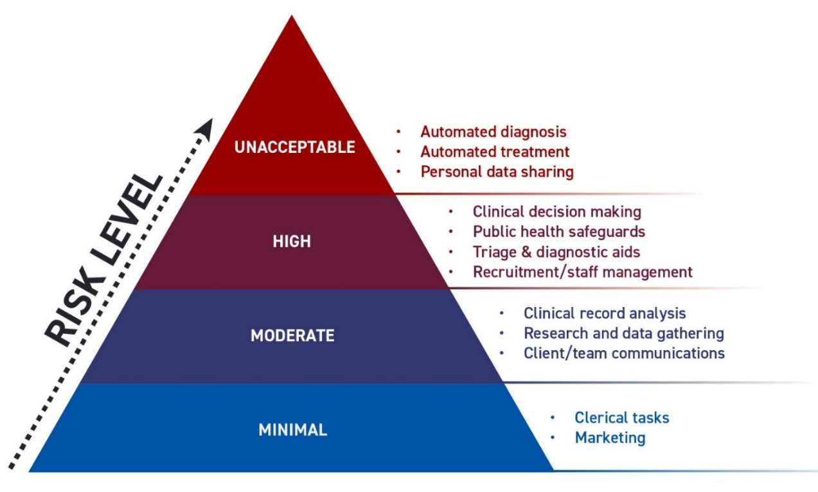
BVA AI use case (a specific situation in which a product or service could potentially be used) risk pyramid modelled on EU AI Act Legislation papers.

Like other types of security risks, AI risk can be understood in terms of how likely a potential threat is to impact an organisation and how much damage that threat would cause. Assessing the risk of an AI system involves looking at the system itself and the use case for that system. The above pyramid, developed by the British Veterinary Association, is a helpful tool to support vet teams in classifying the risks of using AI in different veterinary settings. The list is not exhaustive but shows some of the currently more common or considered use cases and how they may be classified.

Dos and Don’ts of AI use in veterinary practice
- Only tools approved by the [practice name] should be used by employees [link to list here]
- The veterinary surgeon involved in a case remains responsible for all decisions made, regardless of AI involvement. All AI outputs impacting animal care must be considered and approved by a veterinary surgeon.
- You may use AI for routine tasks such as spelling and grammar checks without further approvals.
- You must always ensure clients are aware when the environment is being recorded, either by discussing this with clients directly or by putting up appropriate signage.
- If clients do not wish to have conversations recorded, they must be given the chance to opt out.
- You must always critically assess the output of AI tools for accuracy and reliability when analysing documents or developing policy and verify the results by cross-referencing them with reliable sources. If in doubt, you should sense check with your line manager or a colleague.
- You must always be transparent about where and how AI is used for example, in content generation or as a diagnostic aid confirming you have checked the validity of the outputs.
- You must always consider and check whether the outputs from general AI tools may be infringing copyright or intellectual property. If in doubt, you must not use the outputs.
- Some AI systems can have inherent biases and perpetuate stereotypes, so when using AI you should always be careful that it has not produced content that is inconsistent with [Practice name] EDI policy.
- Tools employing AI in the interpretation of samples or patient data should only be used after appropriate training and once the results have been reviewed by the veterinary team. The results should only be relied upon when the AI tool has been used in the way it is intended.

European Commission, “Regulatory Framework for Artificial Intelligence,” Digital Strategy – European Commission, 2025, https://digital-strategy.ec.europa.eu/en/policies/regulatory-framework-ai

